|  |
| --- |
| Department of Software Engineering  Mehran University of Engineering and Technology, Jamshoro |

|  |  |  |  |
| --- | --- | --- | --- |
| Course: SWE324 – Distributing Computing | | | |
| Instructor | Rabeea Jaffari | **Practical/Lab No.** | 01 |
| Date | 02 April 2019 | **CLOs** | CLO-4: P3 & P4 |
| Signature |  | **Assessment Score** | 1 Marks |

|  |  |
| --- | --- |
| Topic | To become Familiar with OLTP System Design |
| Objectives | * To Creating applications using Datagram sockets. |

|  |
| --- |
| Lab Discussion: Theoretical concepts and Procedural steps |

|  |
| --- |
| Lab Tasks |
| Submission Date: 09-04-19 |

1. Create RMI program in which server performs basic arithmetic operations.
2. ArithmeticServer

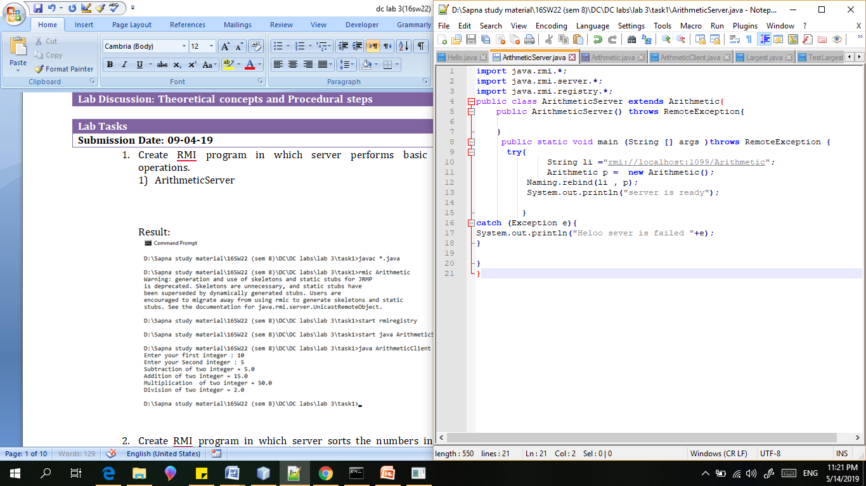

1. Arithmetic:

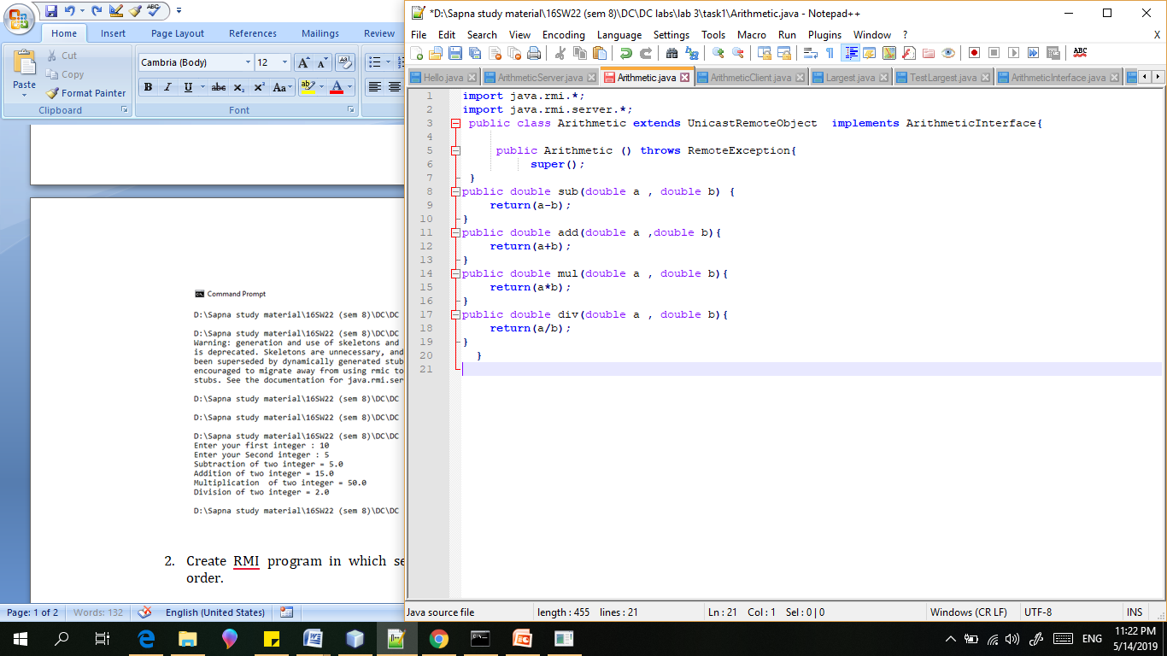

1. ArithmeticClient:

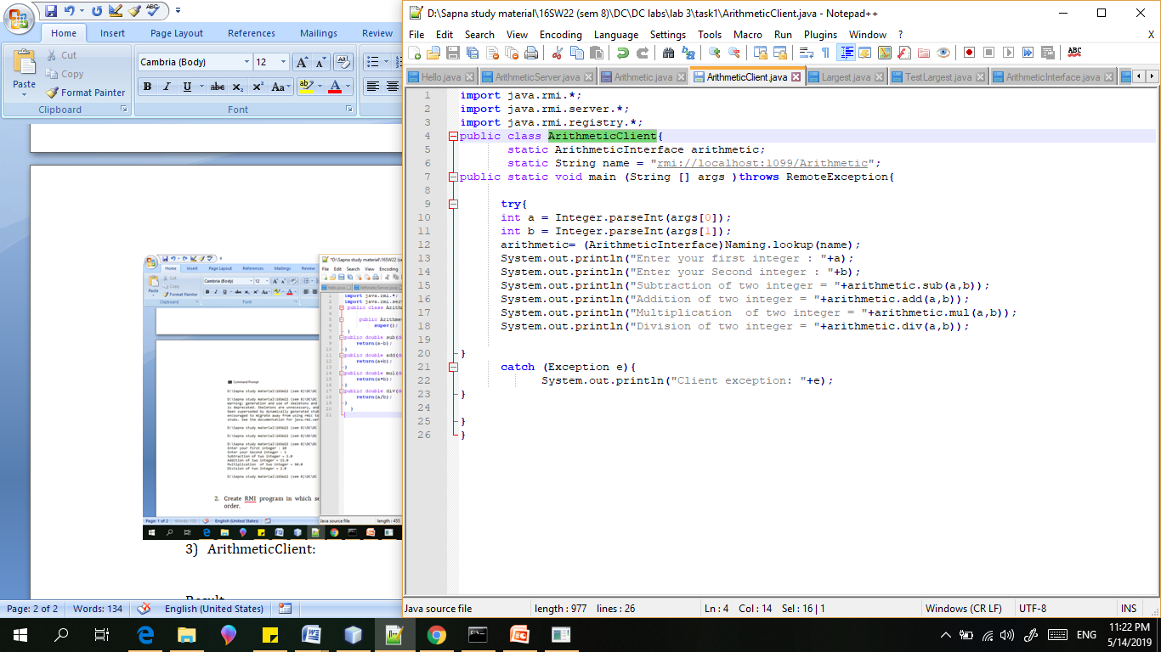

Arithmetic Interface

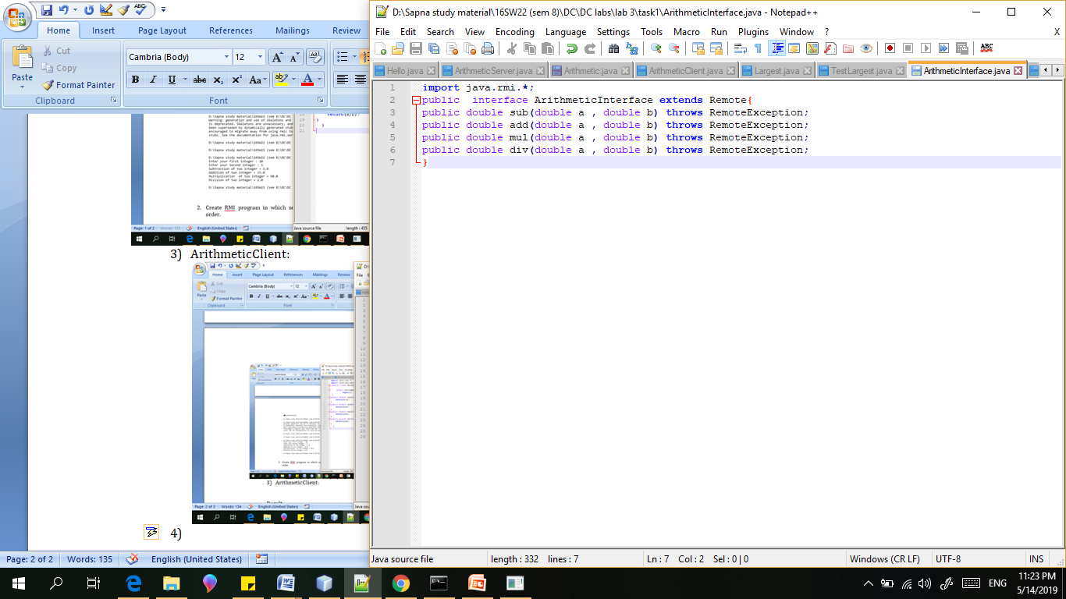

Result:

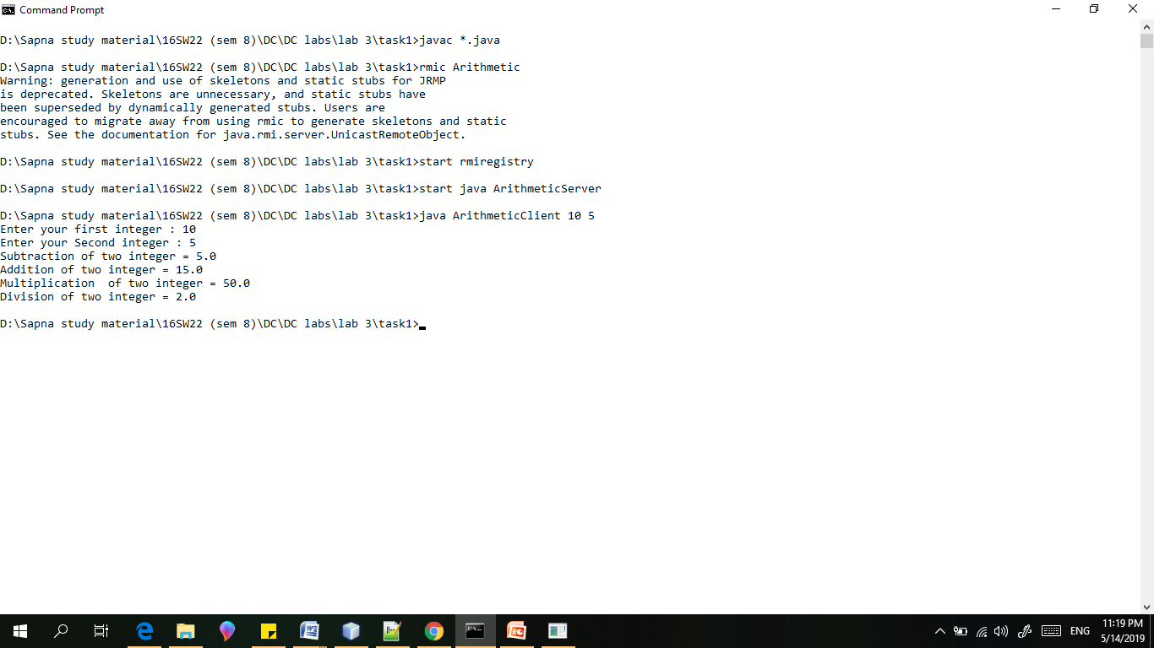

1. Create RMI program in which server sorts the numbers in ascending order.

Code:

1. SortInterface:

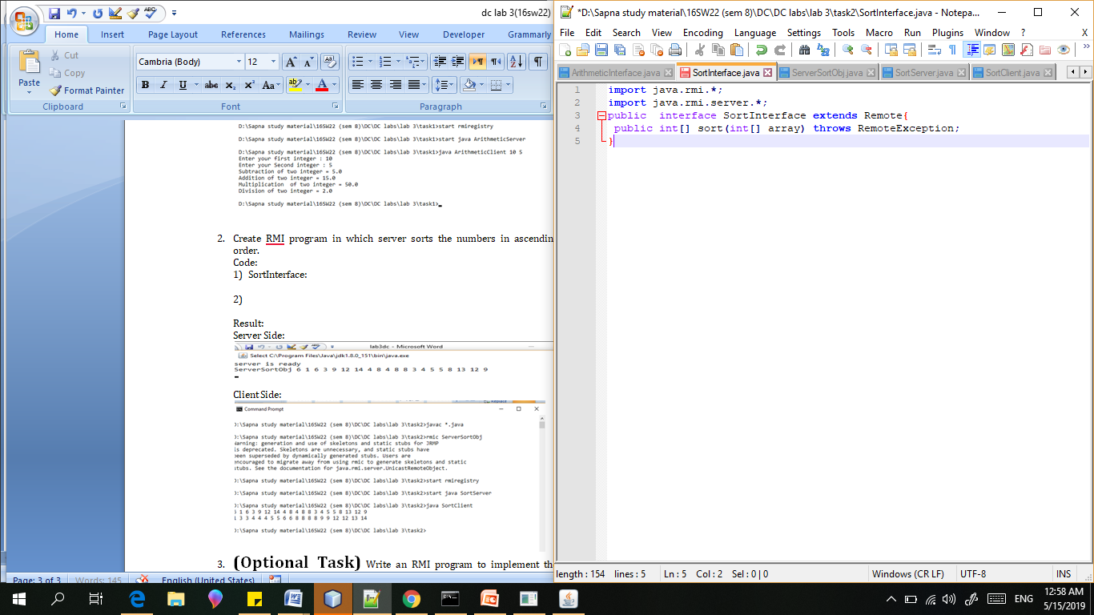

1. ServerSortObj

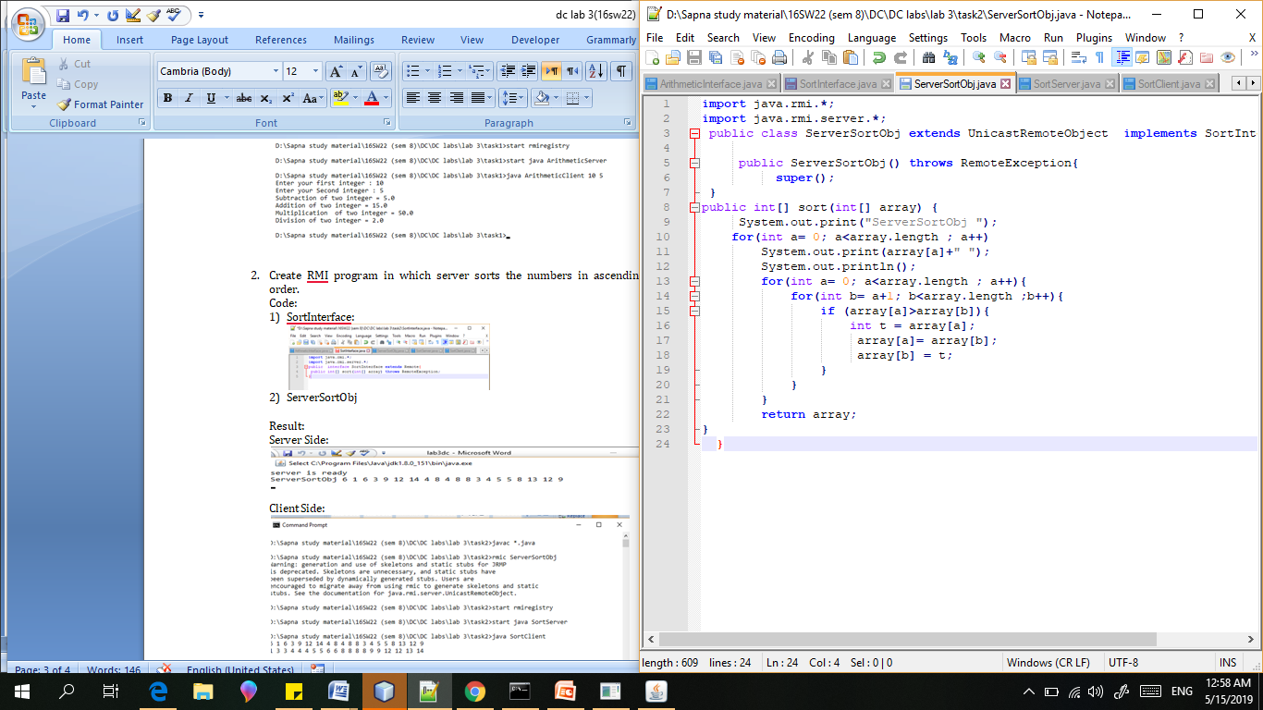

1. SortServer:

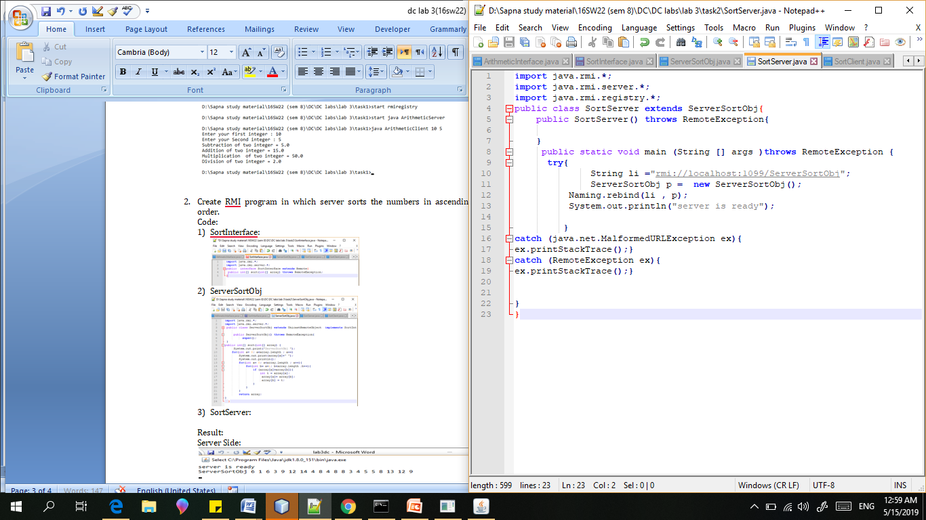

1. SortClient:

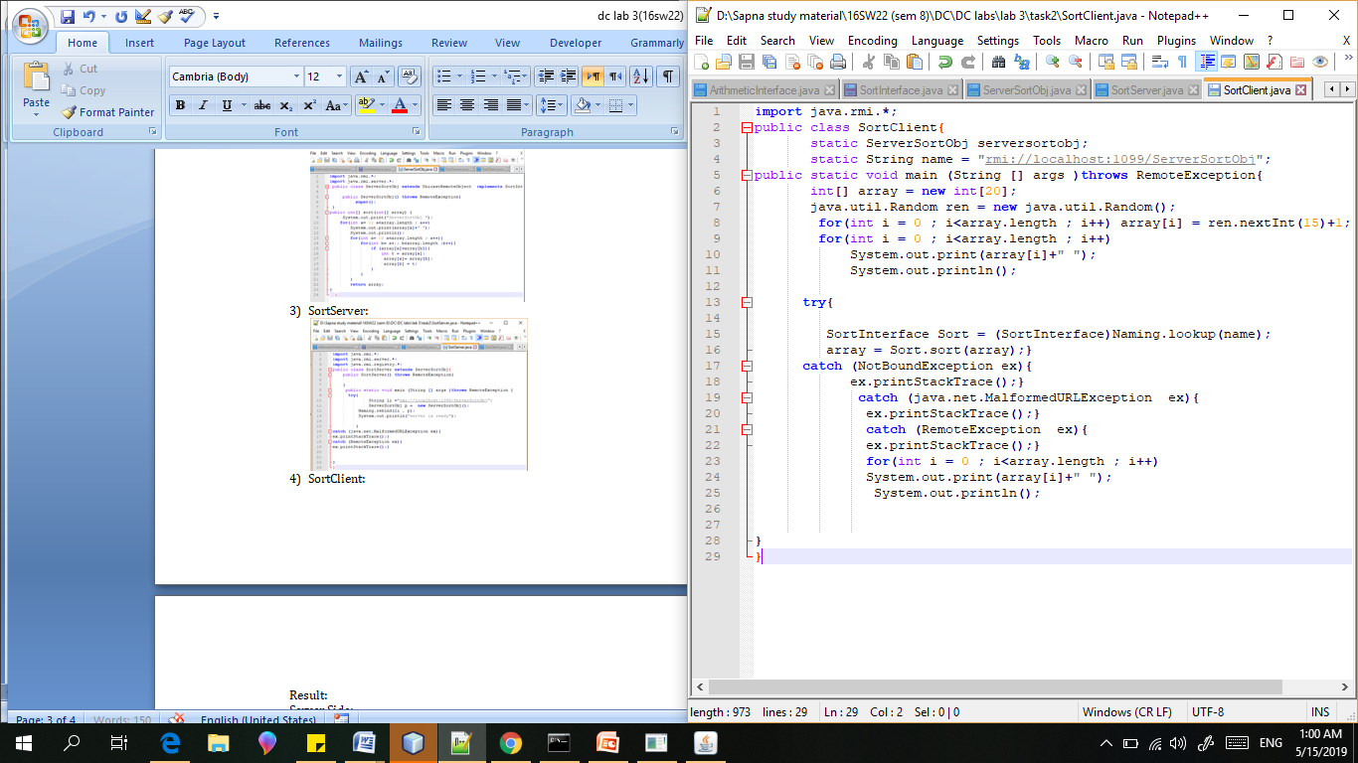

Result:

Server Side:

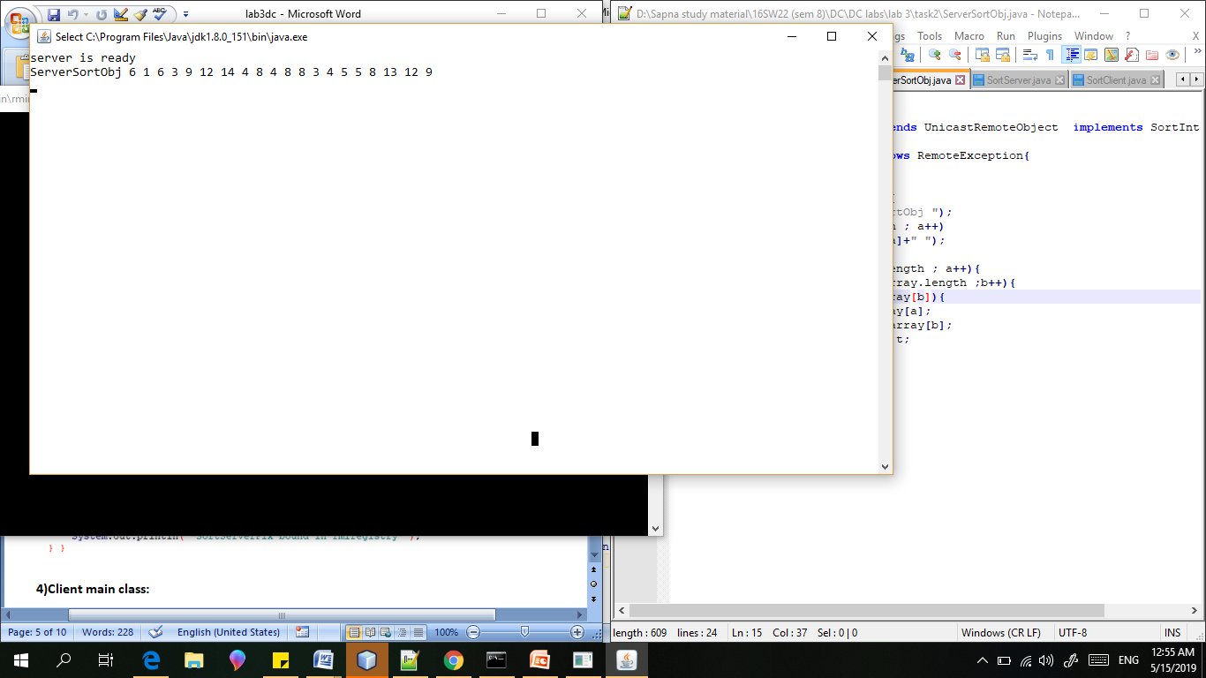

Client Side:

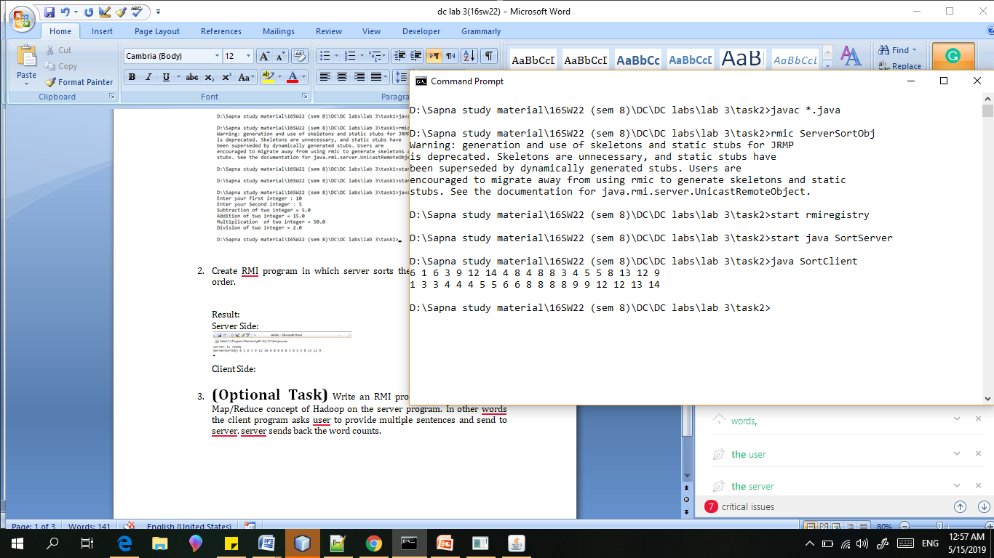

1. **(Optional Task)** Write an RMI program to implement the Map/Reduce concept of Hadoop on the server program. In other words the client program asks user to provide multiple sentences and send to server, server sends back the word counts.
2. WordCountClient

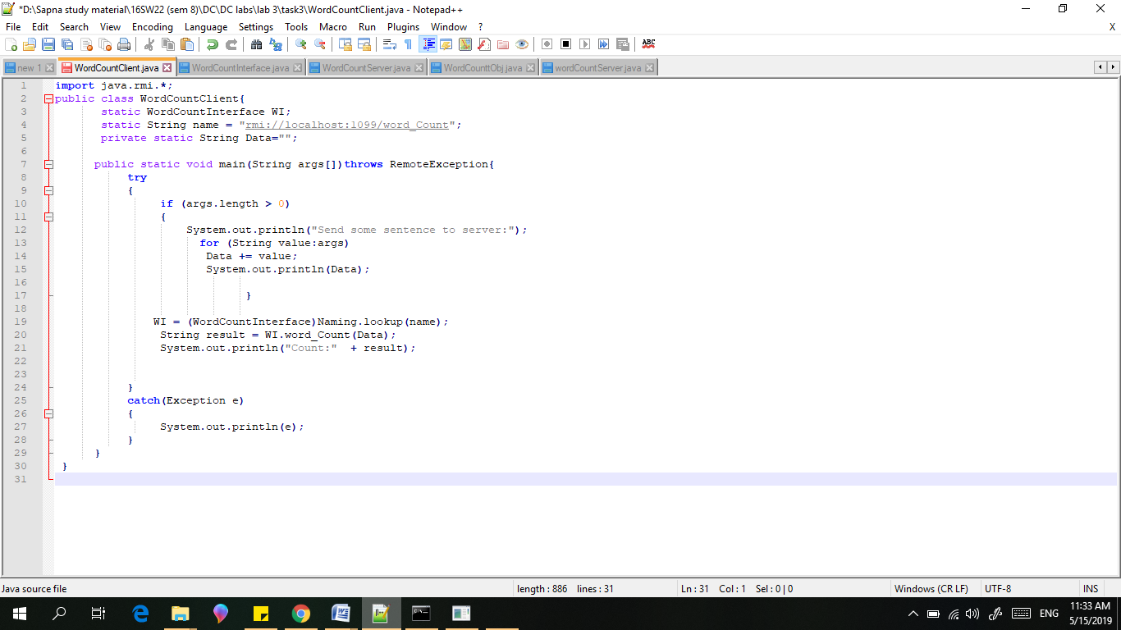

1. WordCountInterface

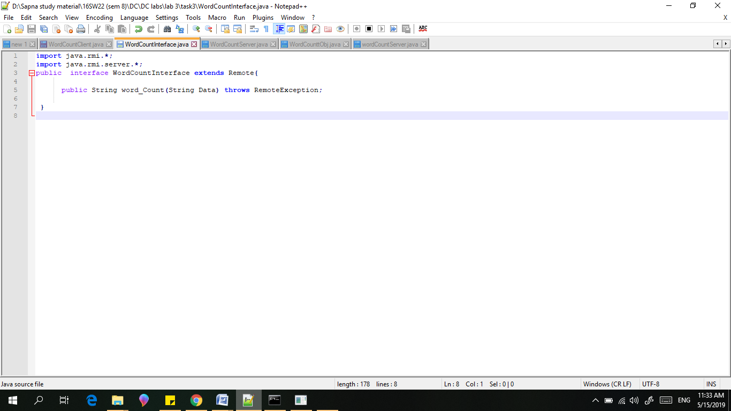

1. WordCountServer

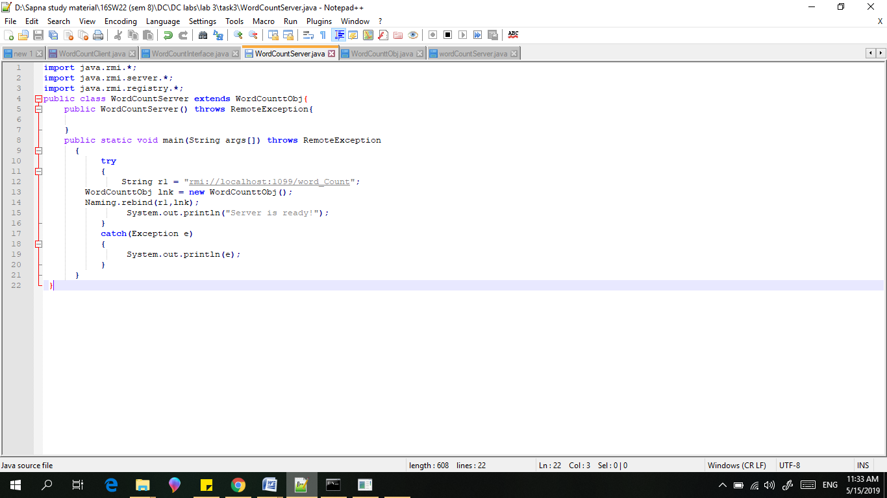

1. WordCounttObj

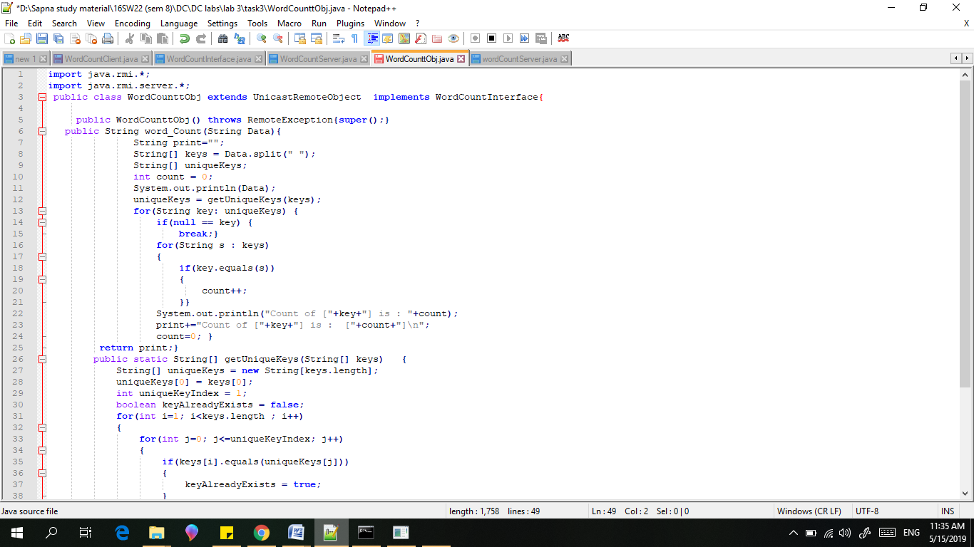

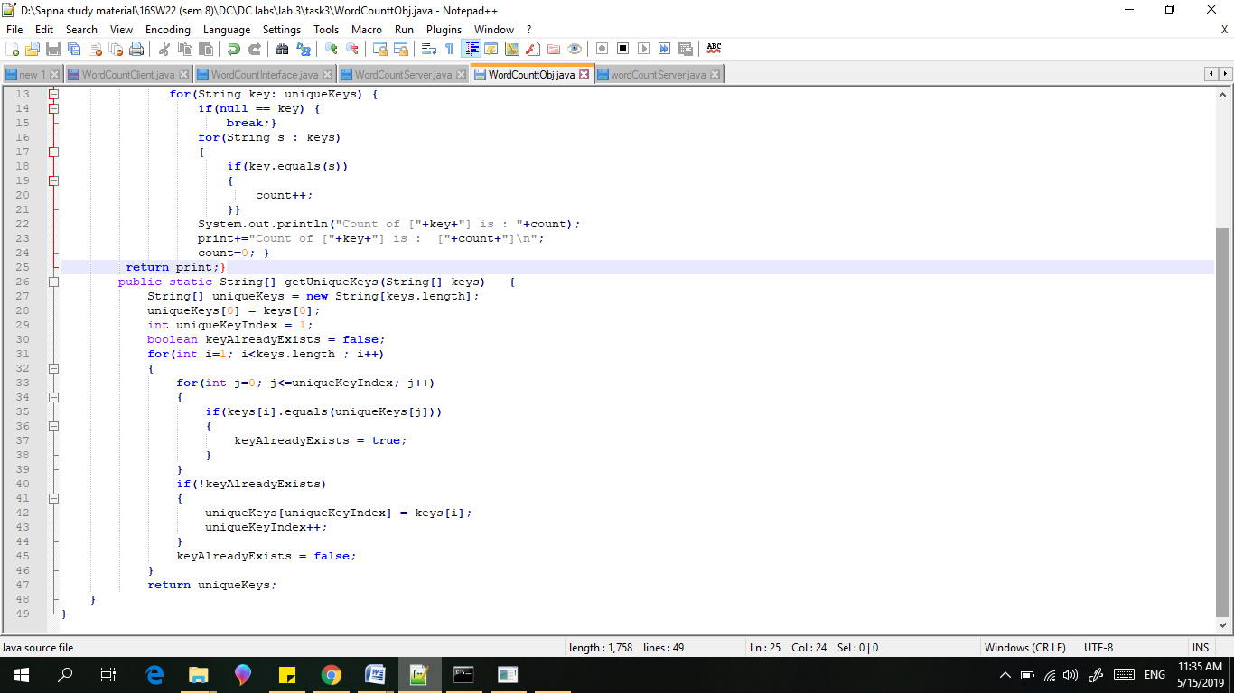

1. wordCountServer

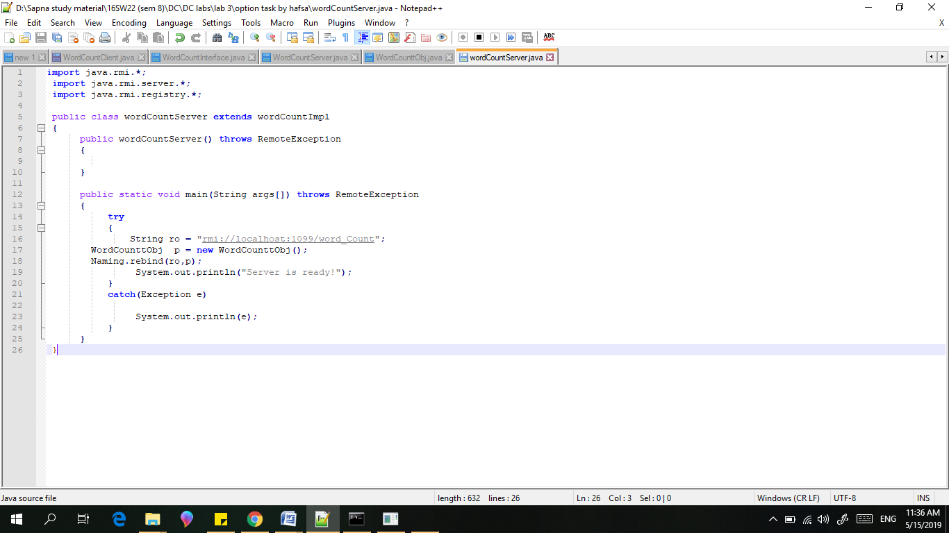

Result::

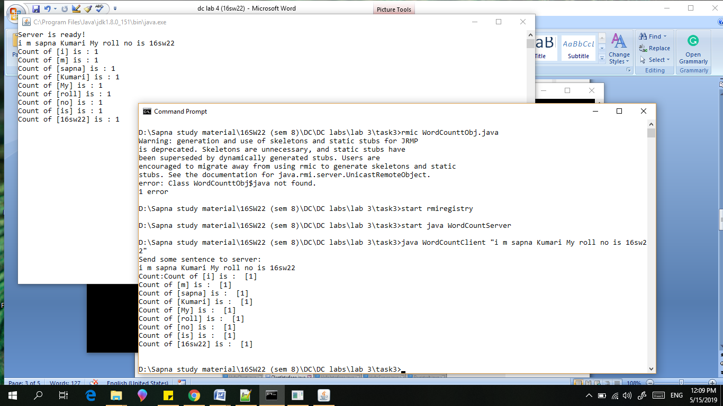

Server:

